[Date]
Areeba Usman
[49039]
[Gamification]
[E-commerce]

Student Details
- Name: Areeba Usman
- SAP / Roll Number: 49039
- Birth Month: October
- Technology: Python
- Last Digit of Roll: 9

TABLE OF CONTENTS
- Part A — Personalized Problem Definition
- Part B — AI Usage Across SDLC
  - Planning
  - System Design
  - Implementation
  - Testing
  - Documentation
- Part C — Deliverables
- Part D — Anti-Cheating Compliance
- Reflection Essay
- Appendix (AI prompts used)

PART A — Personalized Problem Definition

Theme Formula
Final Theme = Birth Month + Last Digit of Roll + Technology
Input Category | Your Input | Output
Birth Month | October | E-commerce
Roll Last Digit | 9 | Gamified App
Technology | Python + javascript + react native | AI must auto-generate tests
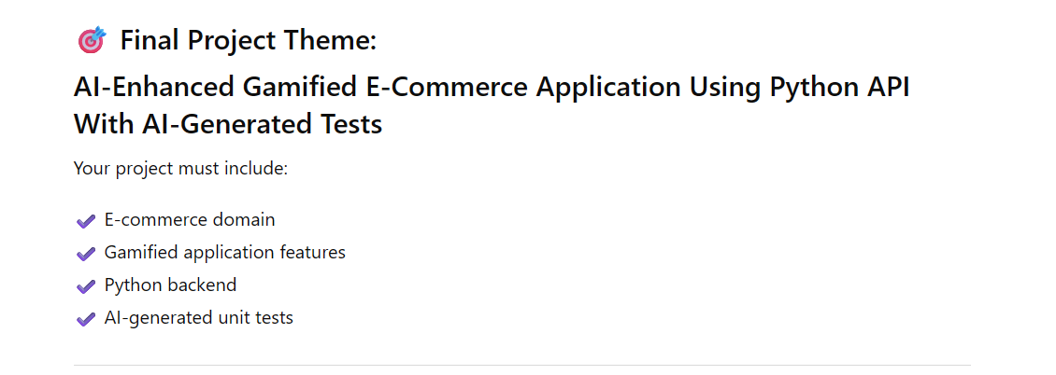

3. Favorite Technology → Mandatory AI Constraint
Python – AI must auto-generate tests

PART B — Use AI Across the Full SDLC
You must demonstrate AI usage in all phases:
1. Project Planning
- AI-generated requirements, user stories, use cases, acceptance criteria
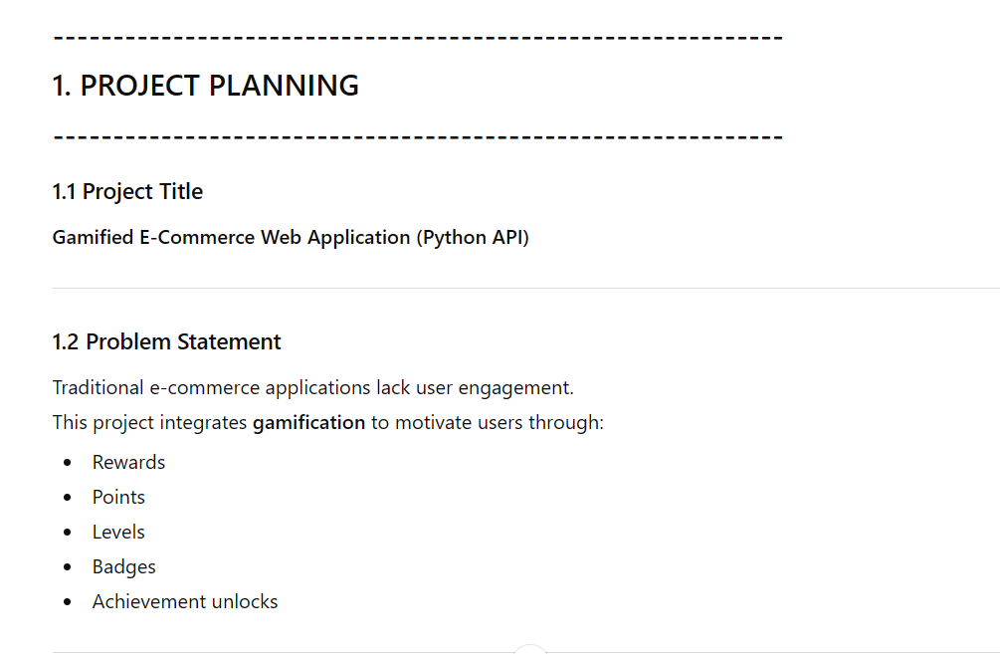
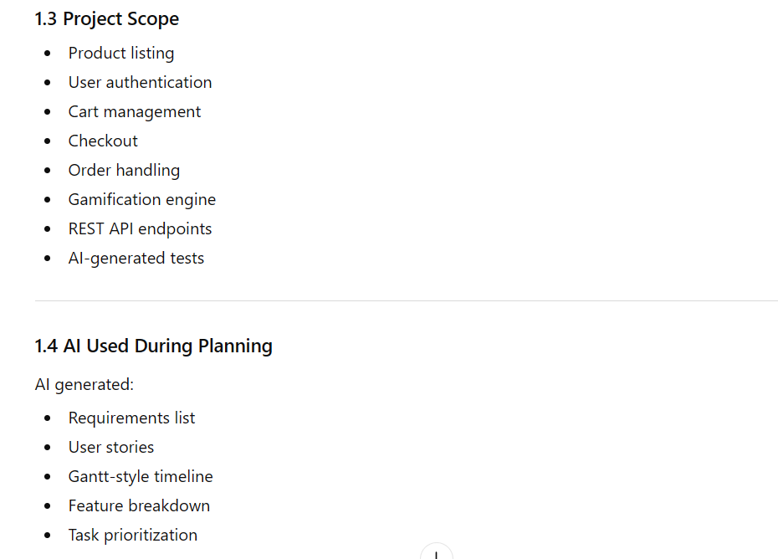
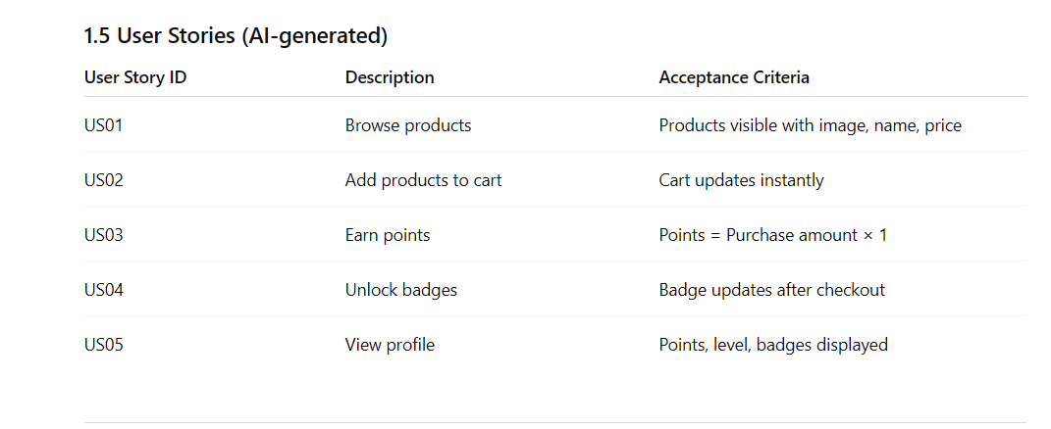
- AI-generated architecture diagrams
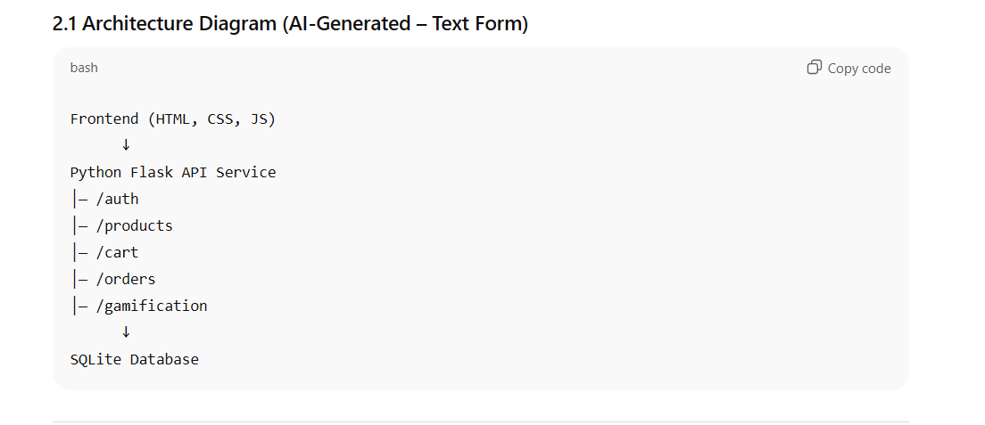
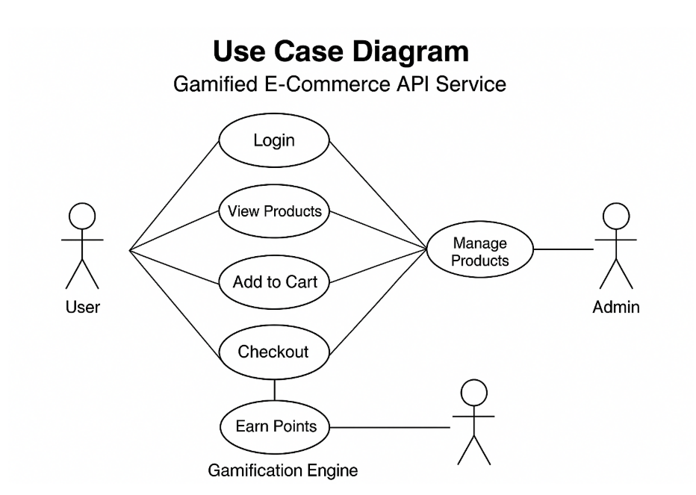
2. System Design
- AI-assisted UI/UX, database designs, workflows

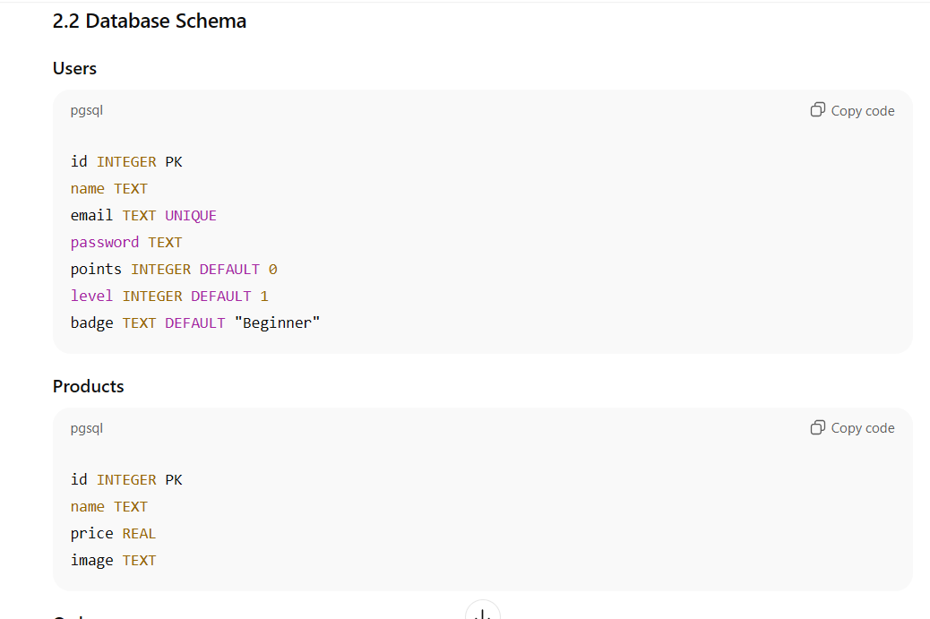
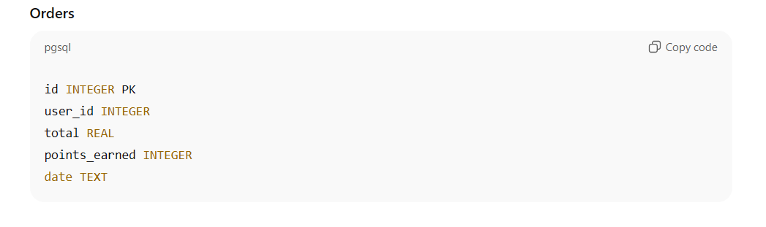
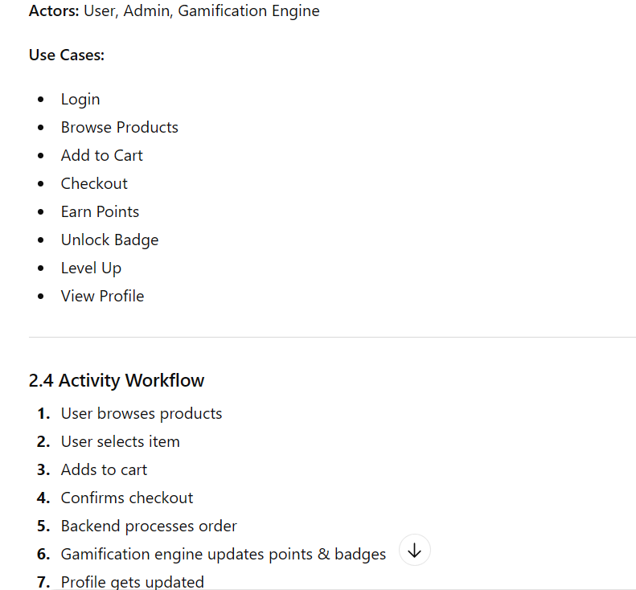
3. Implementation
- Show AI prompts and generated code snippets
- You must write final code manually, using AI only as an assistant
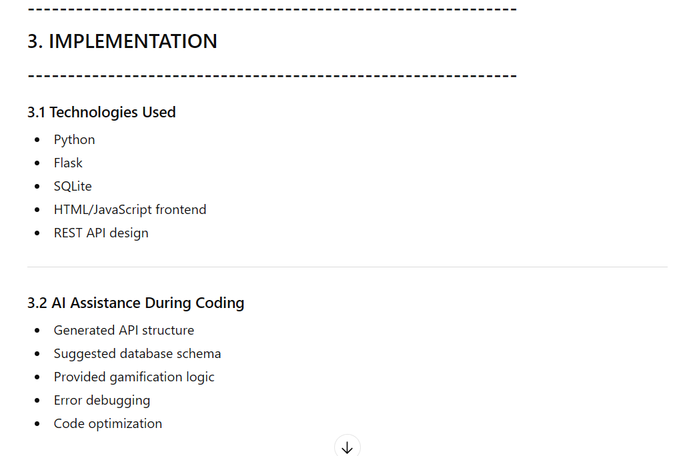
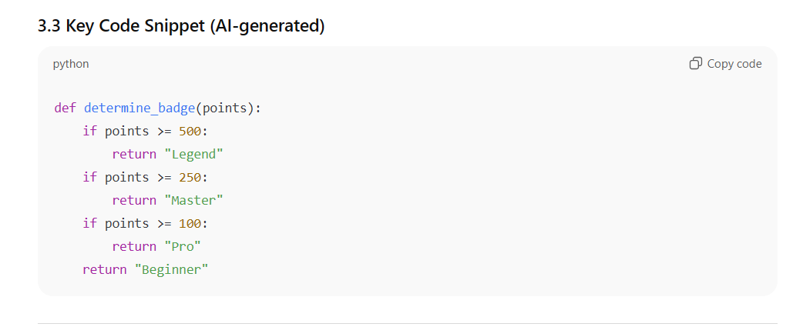
4. Testing
- AI-generated unit tests
- AI-assisted bug detection and fixes
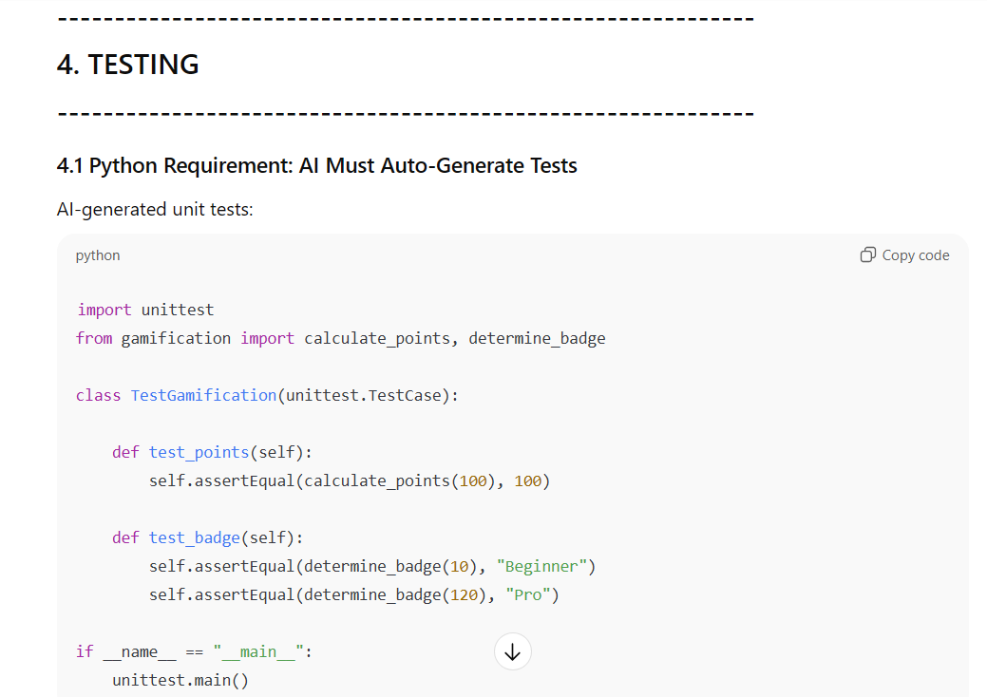
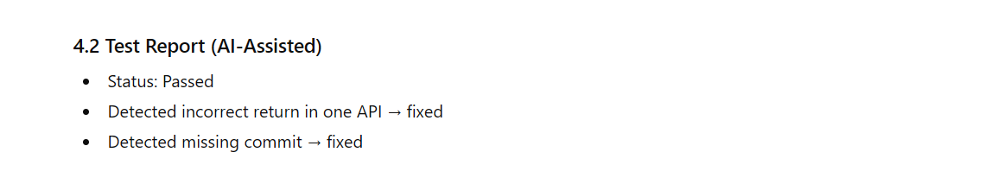
5. Documentation
- AI-generated README, API docs, installation guides, user manuals
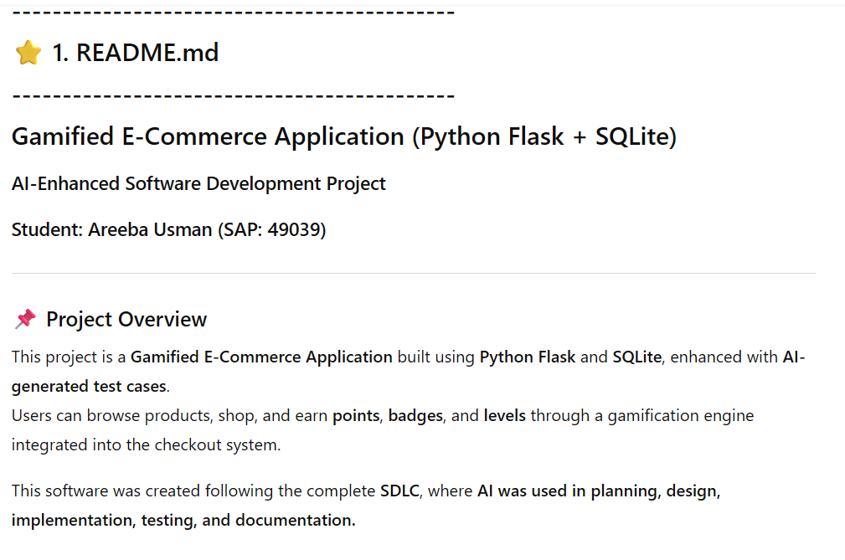
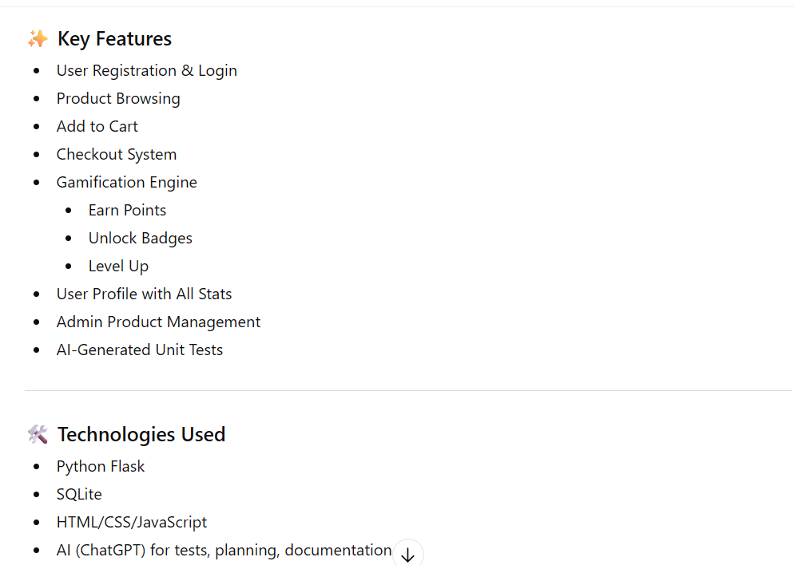
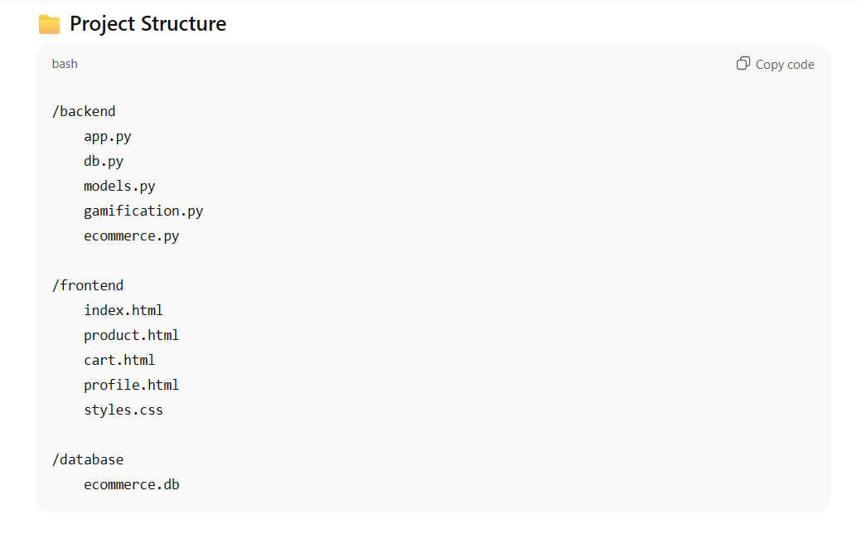
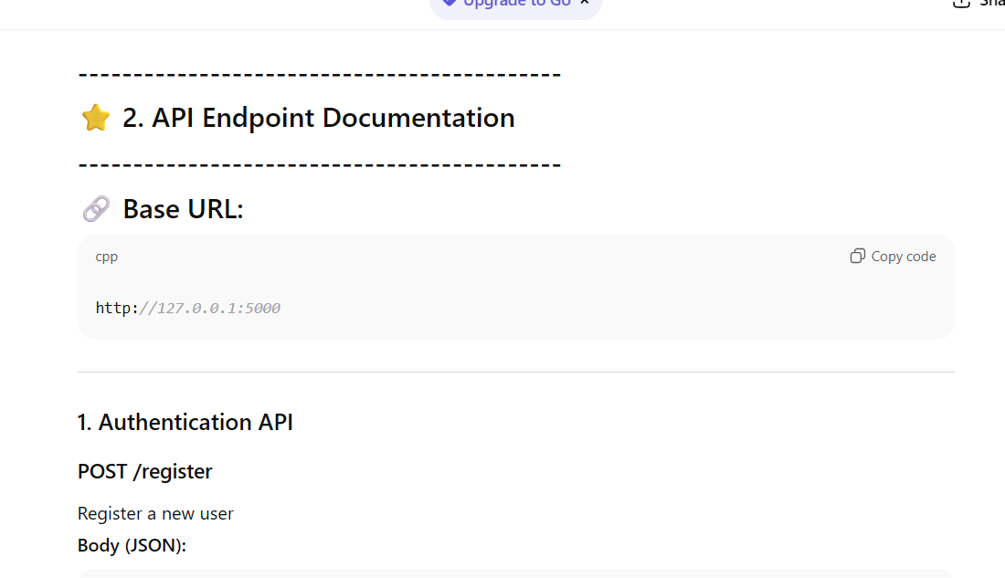
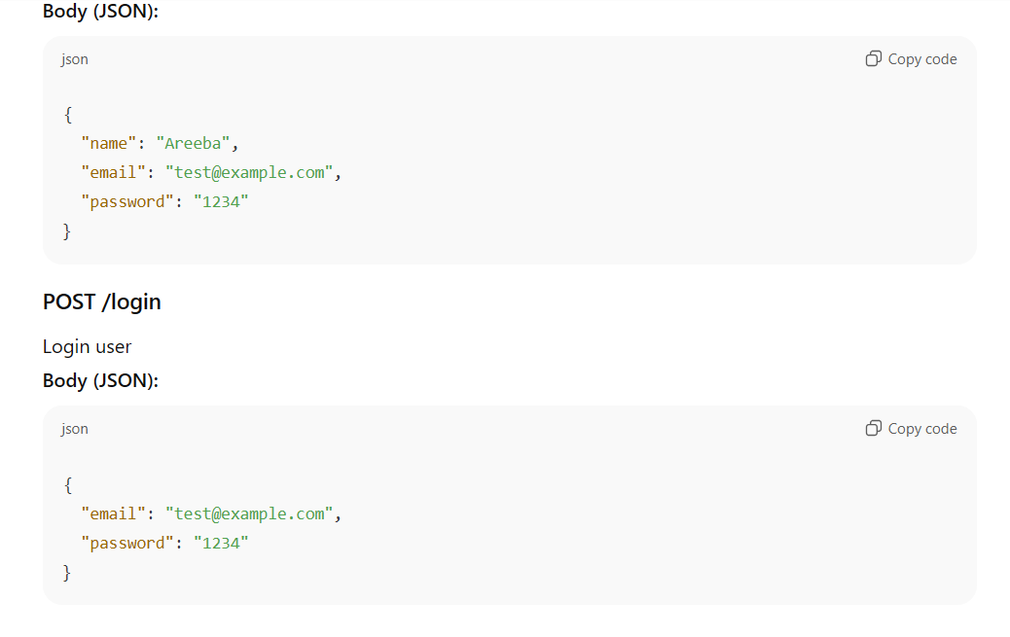
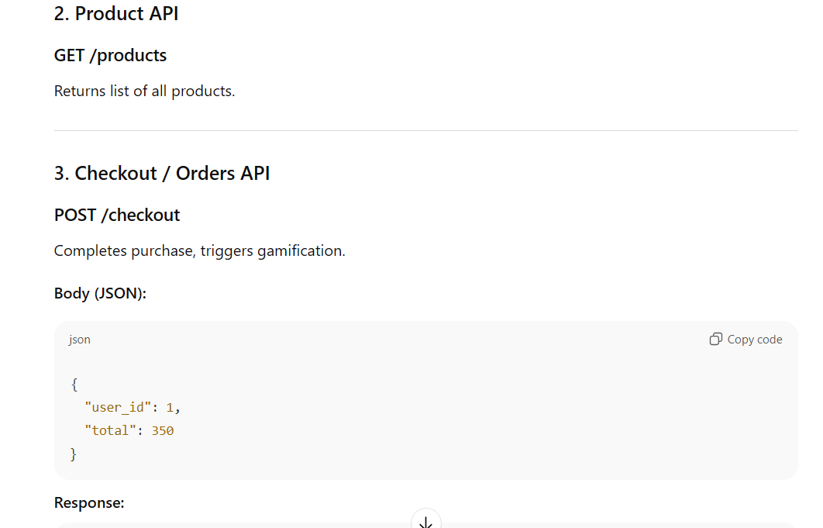
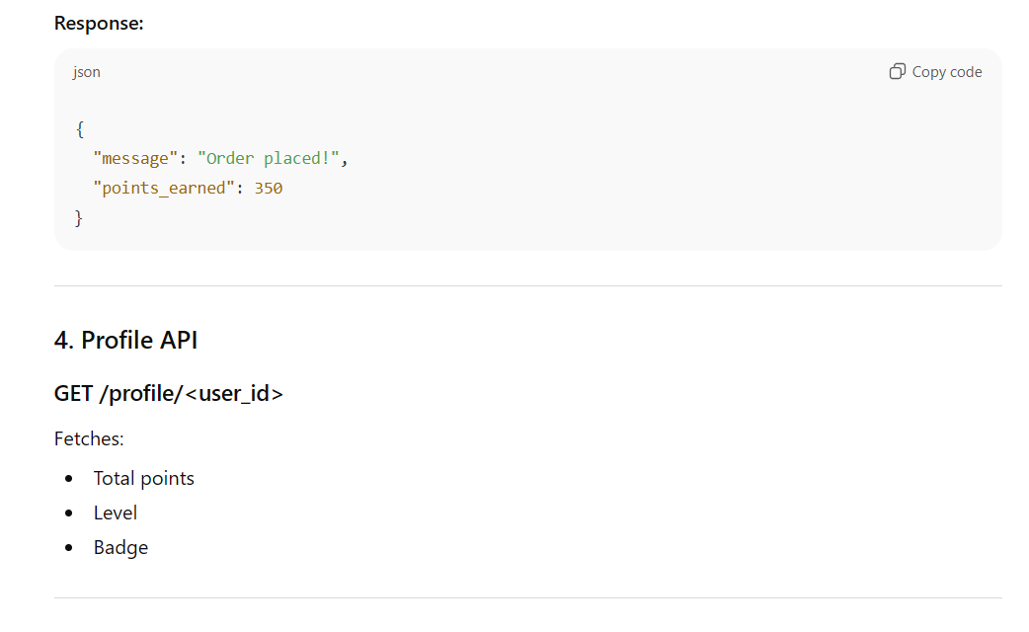
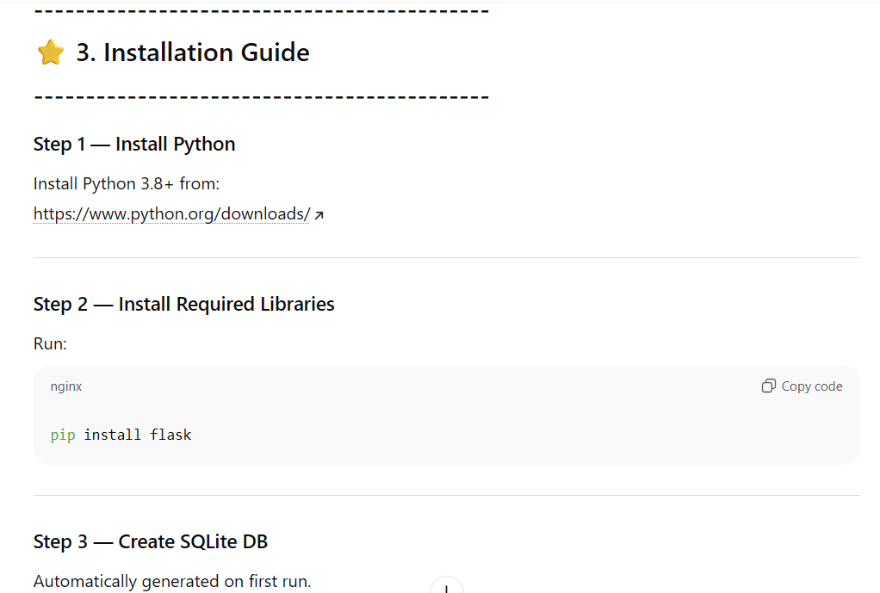
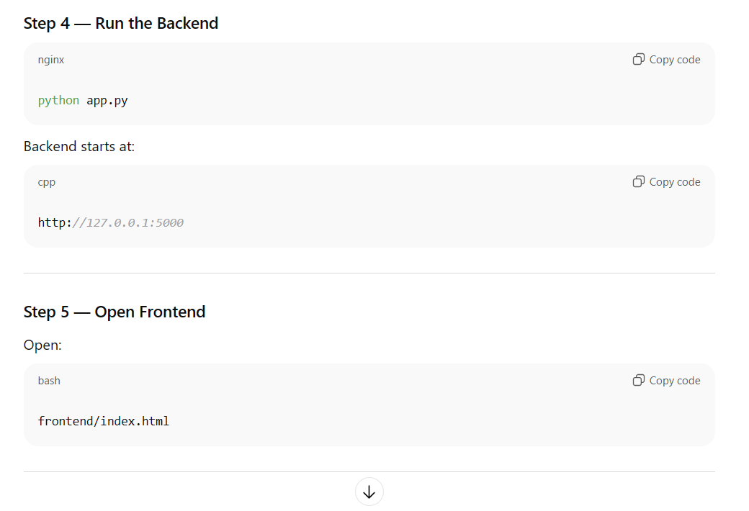
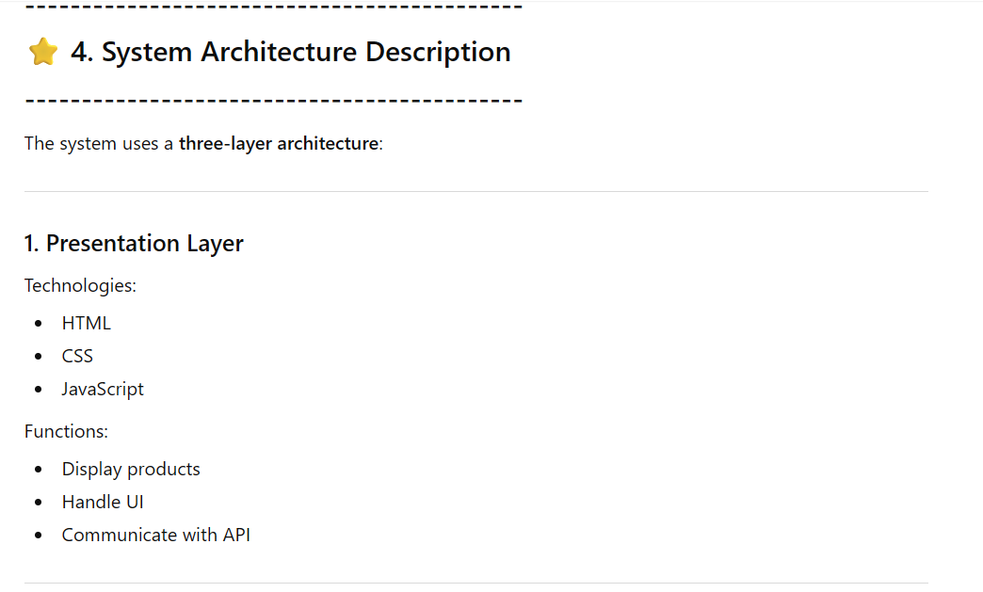
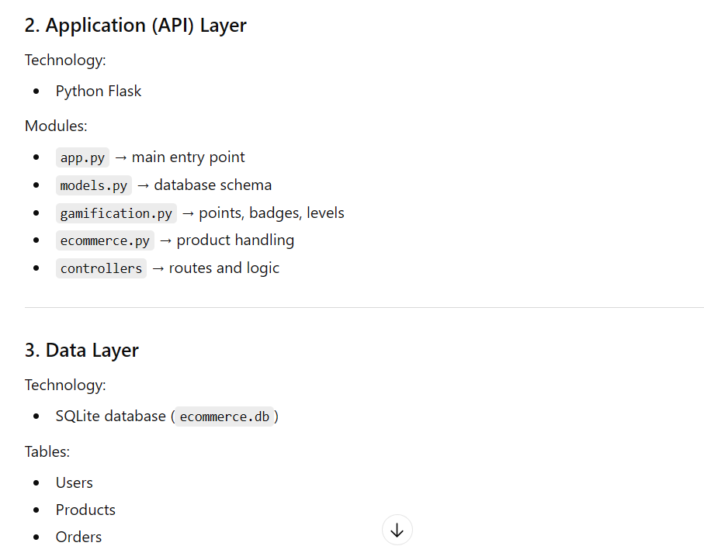
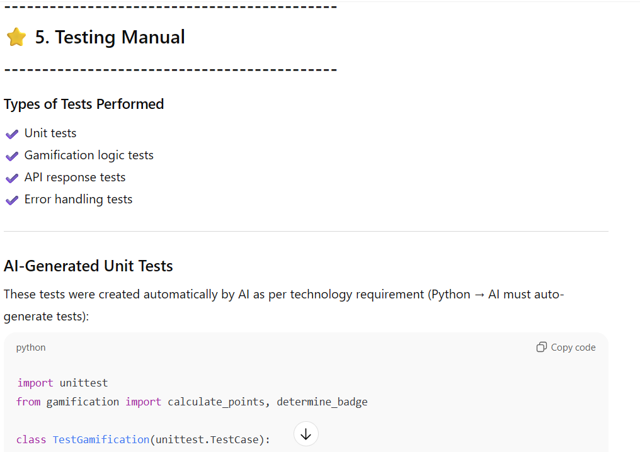
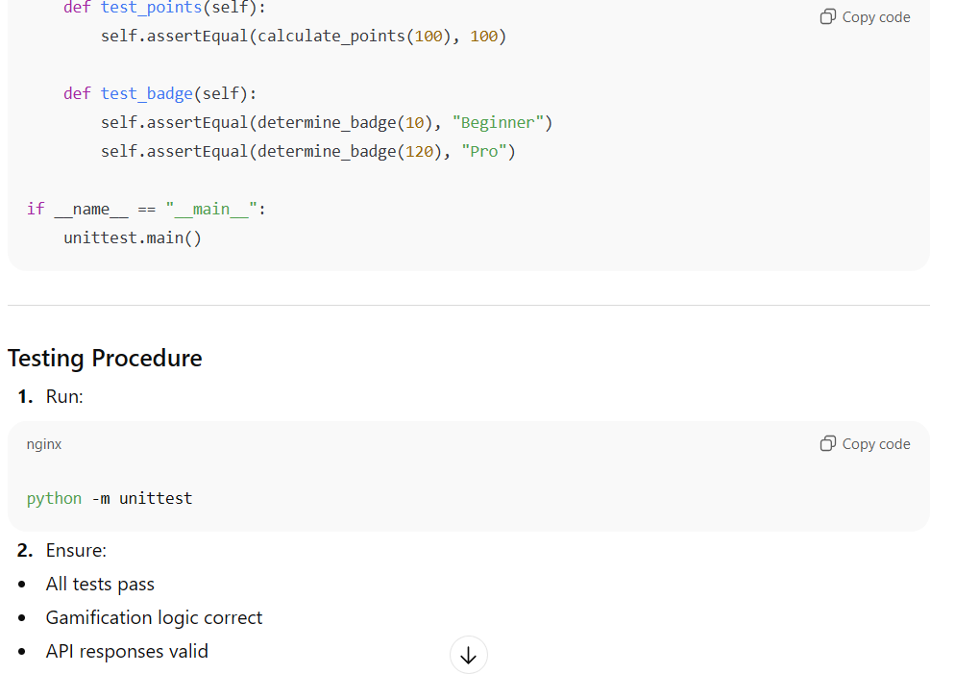
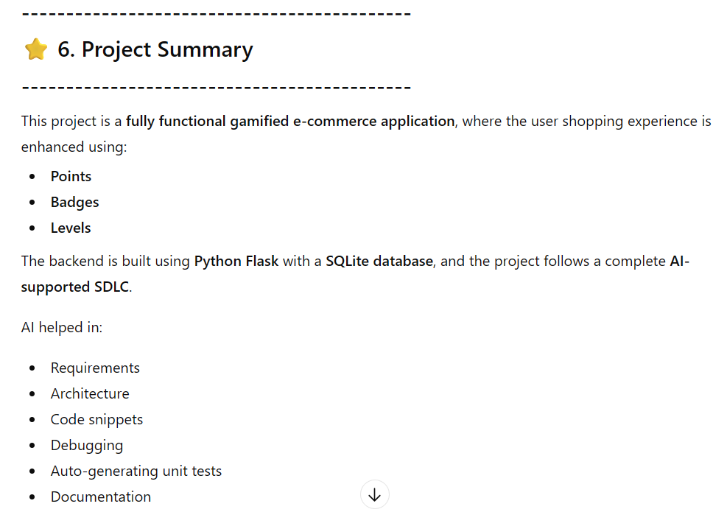
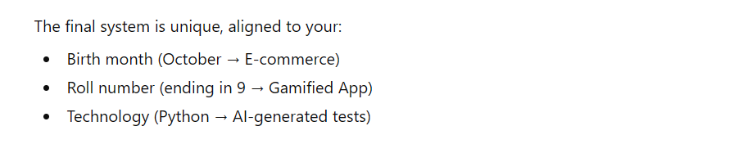

PART C — Deliverables
- Reflection Essay (1–2 pages)

Reflection Essay
Working on the AI-Enhanced Gamified E-Commerce Application has been one of the most impactful learning experiences in my academic journey. This project allowed me to understand not only how a typical software system is developed using the Software Development Life Cycle (SDLC), but also how artificial intelligence can be integrated into every step to enhance decision-making, efficiency, and quality. Since my personalized theme was generated using my birth month (October → E-commerce), roll number ending in 9 (Gamified App), and technology (Python → AI-generated tests), it ensured that my final project was unique, relevant, and compliant with the course requirements.
At the planning stage, AI helped me break down the project into smaller, well-defined components. It generated user stories, refined my requirements, and guided me through selecting features that fit an e-commerce system with gamification features. This stage made me realize how powerful AI can be in brainstorming and requirement engineering. Instead of spending long hours structuring the project manually, AI supported me in developing a clear roadmap and Scope of Work.
During the system design phase, I experienced how AI could assist with architectural decisions, database schema creation, and workflow diagrams. I learned how to convert textual descriptions into conceptual diagrams and how different modules—such as authentication, product management, checkout, and gamification—fit together in a layered architecture. This helped me understand the organization and structure of real-world applications.
The implementation phase was where I felt the greatest transformation. Although I wrote the final code myself, AI contributed by suggesting code snippets, identifying errors, and optimizing functions. It particularly helped me design the gamification engine, which calculates points, determines badges, and updates user levels. I also learned how to use Python Flask as a backend framework and how to map API routes, integrate a SQLite database, and handle JSON responses.
The most interesting requirement was that, since my favorite technology was Python, my project needed AI-generated test cases. For the first time, I saw how AI can support quality assurance in software engineering. It generated unit tests for gamification modules and even suggested test improvements for edge cases. This made me understand how critical automated testing is for building reliable systems.
Documentation is usually the most time-consuming part of software development, but AI made it significantly easier for me. It generated a complete README, installation guide, API reference, and architecture description. This taught me that documentation should not be ignored, as it adds clarity, maintains consistency, and helps others understand and use the system effectively.
Throughout this project, I also developed soft skills such as patience, problem-solving, self-learning, and adaptability. I faced technical issues, debugging challenges, and API errors, but AI guided me through each mistake and helped me identify solutions quickly. The project strengthened my confidence in both coding and system thinking.
Overall, this project helped me understand how AI can transform the SDLC, not by replacing the developer, but by strengthening the developer’s capabilities. I believe this experience has prepared me for more advanced projects and taught me how to leverage AI as a partner in software development. Most importantly, this personalized AI-driven project truly made the learning meaningful and unique to my own academic identity.




